Name: ______________________ Date: ________

**Fill In Proofs (more practice)**

**1.** Given: m∠TOB = m∠WOM

Prove: m∠ TOM = m∠WOB

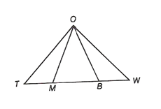

**2. Given: **

**Prove: **



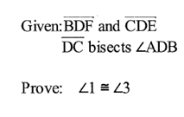**3.**

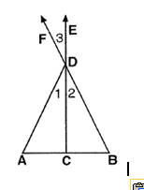

**4. Given: **

**Prove: **



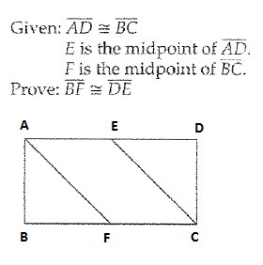**5.**